

**Press Release**

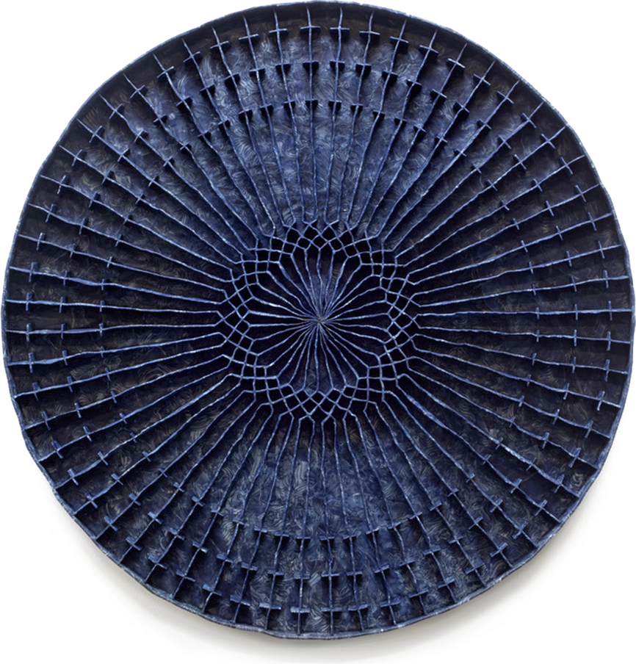

**Window Installation, Circular Persuasion**

**by**

**Levi Van Veluw**

**Dates:** November 2020 – January 2021

Eduardo Secci Contemporary is pleased to present the last site-specific installation by the Dutch artist Levi Van Veluw. “Window Installation, Circular Persuasion”, lasting until January 2021, is always visible to the public in Lungarno Acciaioli 14, Florence.

Right in the heart of the town of Florence, Levi Van Veluw’s first window installation with its bright colours and immersive atmospheres invites whoever passes by to contemplation. Visible at any time of the day, the project redefines the space it occupies charging it of an aura of spirituality. Floating in the space is “Circular Persuasion”, a sculpture made working the clay entirely by hands and as such betraying an authentic, coarse and organic character. The body of water filling the down part of the ambient stands as a purifying element within the installation. The architecture, progressively converging towards a central vanishing point occupied by the blue circular sculpture, seems to recall a religious construction such as the presbytery of a church. Thus, the carefully constructed shapes and patterns exude a timeless character prompting an euphoric holy experience. Inaugurated in one of the most challenging historical moments of contemporary society, the work embodies a story of the past, the present and the future capable of transcending contingency and offering spiritual restoration to the eyes of the comers, just like holy places did to religious pilgrimages.

Van Veluw, born in The Bible-belt, with a grandfather who was a minister, has been fascinated with the church and its rituals since his early youth. Not only the complexity, conviction and certainty with which the faith was proclaimed in his congregation and the stark visual language of its practice made him sensitive to the visual vernacular of religious seduction.

Yet also modern spiritual movements, such as the well-known Church of Scientology, that use religious symbols in a convincing manner, intrigue him as well. Throughout the ages, in cultures around the world, religion has played an important role in the development of art, architecture

and storytelling. Even if spirituality is ultimately immaterial, most people practice their faith in places of worship, and make use of sacred objects and perform sacred rituals.

Van Veluw has meticulously studied the rich formal language and power of imagination that is used to lead people to religious faith. Within this research, he is particularly interested in the aspects of the religious process. He chooses not to focus on political issues surrounding faith, but rather explores how the various faiths operate in the mind of the faithful through form and image. Similarly he investigates whether he, as an artist, is capable of provoking a convincing spiritual experience in the visitor. Through the use of light, symmetry and harmony—often utilized to depict the pursuit of divine perfection—as well as forms reminiscent of altars, idols and temples, he manages to evoke a sacral experience. The experience of walking into his installations resembles that of treading on holy ground.

Among Levin Van Veluw’s personal recent exhibitions we remind: Domaine de Kerguéhennec, Bignan (2018); Tenuta Dello Scompiglio, Italy (2019); La Galerie particuliere, Paris (2017); Galerie Ronmandos, Amsterdam (2019); Rosenfeld Porcini Gallery, London (2016). Among group shows we remind: Museo Kranenburgh, Netherlands (2017); Labellisée Normandie Impressonniste, France (2016); Museum De Fundatie, the Netherlands (2016); Maddox Arts, London (2015). Van Veluw’s works have also been widely shown at international art fairs such as Zona Maco (2018), The Armory Show, New York (2017), Art Brussels (2016), Chicago Art Fair (2016), Volta Basel (2012), and the Barcelona Loop Fair Barcelona (2014). The work of Levi Veluw has been exhibited internationally in leading museums and institutions, and is included in both public and private collections, including the Borusan Collection, the Caldic Collection, the Ekard Collection and Kpmg.

.

**Press Office**

**exhibitions@eduardosecci.com**

(+39) 055.661356

We invite you to join the conversation with Eduardo Secci Contemporary on:

Instagram: @eduardoseccicontemporary @levivanveluw

Facebook: Eduardo Secci Contemporary

and by using the following hashtags:

#eduardoseccicontemporary #levivanveluw #florence #site specific installation