East African Masters
October 2022
Comwell Place, Gallery 12
11 - 16 October

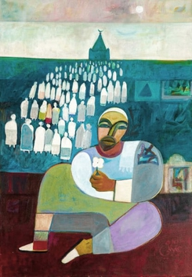 | Mohamed Abdella Otaybi  The Dervish (II), 2020  Acrylic on canvas  99 x 69.5 cm  39 x 27 3/8 in | £4072
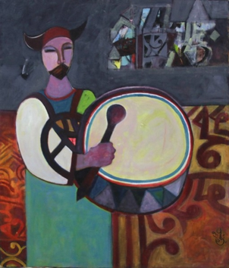 | Mohamed Abdella Otaybi  The Dervish (I), 2019  Acrylic on canvas  77.5 x 65.7 cm  30 1/2 x 25 7/8 in | £3870
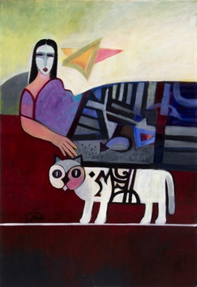 | Mohamed Abdella Otaybi  Playing Cat, 2021  Acrylic on canvas  89.5 x 59.5 cm  35 1/4 x 23 3/8 in | £3870
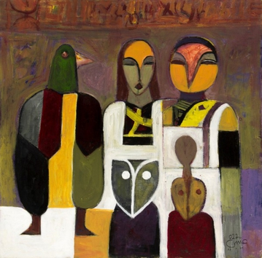 | Mohamed Abdella Otaybi  Conversations, 2022  Acrylic on canvas  50.3 x 50.3 cm  19 3/4 x 19 3/4 in | £1688
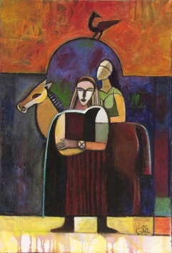 | Mohamed Abdella Otaybi  Displacement, 2021  Acrylic on canvas  74.5 x 50 cm  29 3/8 x 19 3/4 in | £3690
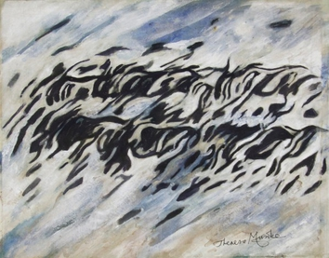 | Theresa Musoke  Wildebeest (in blue and black), Undated  Oil on canvas  81 x 101 cm  31 7/8 x 39 3/4 in | £4500
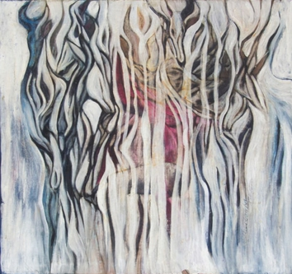 | Theresa Musoke  Hartebeests (in blues and pink), Undated  Oil on canvas  116 x 78 cm  45 5/8 x 30 3/4 in | £5400
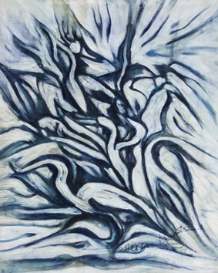 | Theresa Musoke  Egrets in blue, Undated  Oil on canvas  80.1 x 65.6 cm  31 1/2 x 25 7/8 in | £2475
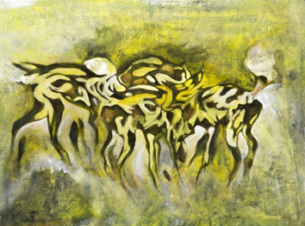 | Theresa Musoke  Wild Dogs I (Yellow), c. 1990s  Mixed media on canvas  77 x 104 cm  30 1/4 x 41 in | £5040
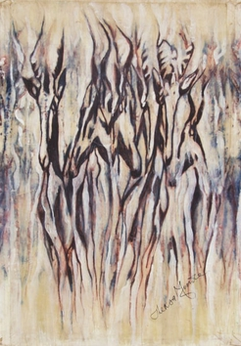 | Theresa Musoke  Hartebeest in browns and purple, Undated  Oil on canvas  116.5 x 79.5 cm  45 7/8 x 31 1/4 in | £4950
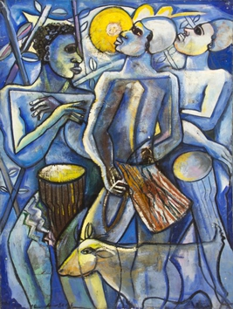 | Geoffrey Mukasa  Dancer and Musicians and sheep in blue, Undated  Oil on canvas  121 x 91.5 cm  47 5/8 x 36 in | £13,500
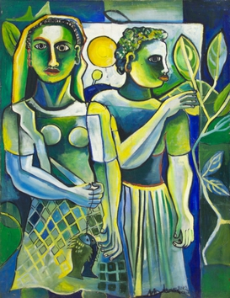 | Geoffrey Mukasa  Couple in Green with Sun, Undated  Oil on canvas  121 x 92 cm  61 1/4 x 25 3/8 in | £13,500
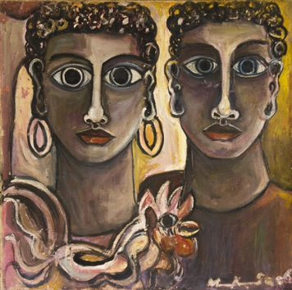 | Geoffrey Mukasa  Two Ladies with Cockerel, 2007  Oil on canvas  60 x 60 cm  23 5/8 x 23 5/8 in | £5625
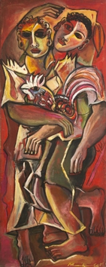 | Geoffrey Mukasa  Couple with Cockerel, ca. 2005  Oil on canvas  152 x 60 cm  59 7/8 x 23 5/8 in  155.5 x 64 cm (framed) | £9,900
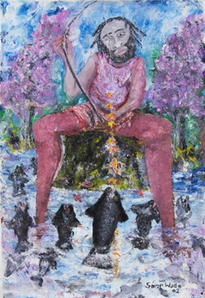 | Sane Wadu  Self Portrait as Fisherman, 1980s  Oil on canvas  134.5 x 81.5 cm  53 x 32 1/8 in | £4050
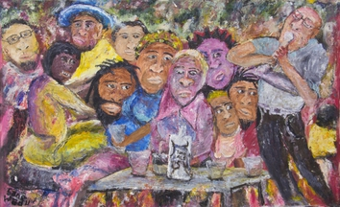 | Sane Wadu  Artist party  Oil on canvas  56.7 x 91.7 cm  22 3/8 x 36 1/8 in | £4050
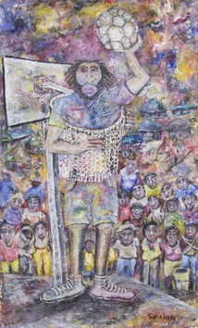 | Sane Wadu  A Tough Defender  Oil on canvas  134 x 81 cm  52 3/4 x 31 7/8 in | £4950
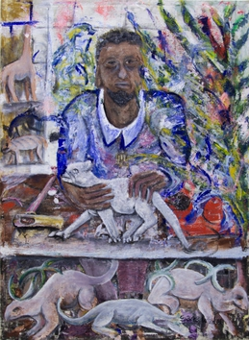 | Sane Wadu  Curio Artist, Undated  Oil on canvas  88 x 64 cm  34 5/8 x 25 1/4 in | £4050

